**小学三年级英语期末试卷**

一、选出你听到的单词。1×10

（ ）1. A. painting B. shopping

（ ）2. A. Australia B. America

（ ）3. A. France B. friends

（ ）4. A. from B. for

（ ）5. A. live B. love

（ ）6. A. here B. her

（ ）7. A. he’s B. she’s

（ ）8. A. Germany B. Japan

（ ）9. A. Canada B. Britain

（ ）10. A. work B. worker

二、听句子，判断图片是否与听到内容相符？每段对话读两遍。相符用“√”表示，不相符用“×”表示。1×5

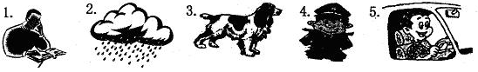

（ ） （ ） （ ） （ ） （ ）

三、根据所听内容选择正确的答语。1×5

（ ）1. A. He is my uncle. B. She is my aunt.

（ ）2. A. He is a waiter. B. She is a dentist.

（ ）3. A. Yes, he can. B. No, he can’t.

（ ）4. A. Yes, she is. B. No, she isn’t.

（ ）5. A. He is a fireman. B. Peter wants to be a policeman in the future.

四、根据听到的对话内容，将下列图片依次排序，将序号填在括号里。2×5

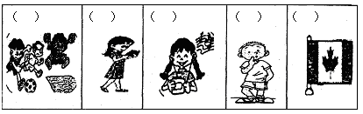

五、听，将每个人的姓名及其相关信息填入下面表格。所缺单词请参考旁边的词汇表。1×10

Word bank

|  |
| --- |
| four, five, seven,  eight, nine, ten, eleven,  twelve, quiet, shy,  active, funny, smart,  small, pretty |

|  |  |  |
| --- | --- | --- |
| Name | age | Character（性格） |
| Ken |  |  |
| Carol |  |  |
| Anna |  |  |
| Tom |  |  |
| Cathy |  |  |

笔试部分

一、先认一认，再找出每组中不属于同类的单词，并将其标号填在题前括号里。2×5

（ ）1. A. turkey B. swan C. coach D. crane

（ ）2. A. sister B. brother C. mother D. tailor

（ ）3. A. France B. T-shirt C. Japan D. Germany

（ ）4. A. waiter B. fireman C. driver D. maths

（ ）5. A. hot B. green C. pink D. blue

二、选择填空。2×8

（ ）1. I am _________ Class 1, Grade 5.

A. on B. in C. at

（ ）2. My uncle _________ Japan.

A. is from B. come from C. comes in

（ ）3. Let me introduce my parents _________ you.

A. for B. to C. of

（ ）4. What’s your aunt? She’s a _________.

A. postman B. actor C. doctor

（ ）5. Here is a photo _________ my family.

A. of B. for C. in

（ ）6. Peter and Bob are _________.

A. twins brother B. twins brothers C. twin brothers

（ ）7. I want to_________ an engineer in the future.

A. have B. be C. do

（ ）8. Susan’s aunt _________ Japan.

A. is B. comes from C. comes in

三、读句子，左右栏的问句与答语对应搭配：2×5

（ ）1. Where does she come from? A. No, he doesn’t.

（ ）2. Does Mary like playing the piano? B. Yes, she does.

（ ）3. Does Peter like writing? C. She comes from France.

（ ）4. Where does she live? D. He lives in Canada.

（ ）5. What’s your sister’s job? E. She is a dentist.

四、读句子，找出与句子内容相符的单词，把标号填在题前括号里。1×4

（ ）1. It’s a large white water bird with a long thin neck.

（ ）2. He works in a hospital. He helps ill people.

（ ）3. He is very kind. He teaches us Chinese.

（ ）4. It has two long ears. It likes to eat carrots.



五、读一读，将图片与相符文字内容连线。2×4

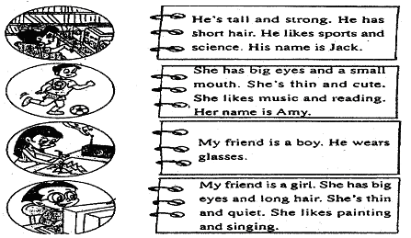

六、画一画你的爸爸和妈妈，让我们认识一下，他们是做什么呢？10

What’s your dad What’s your mum?

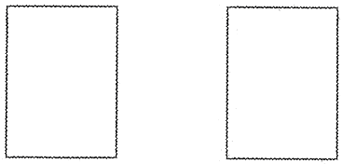

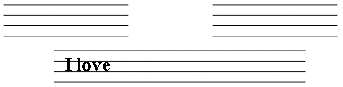

**【试题答案】**

听力部分

一、选出你听到的单词。1×10

（**A**）1. A. painting B. shopping

（**B**）2. A. Australia B. America

（**A**）3. A. France B. friends

（**A**）4. A. from B. for

（**A**）5. A. live B. love

（**B**）6. A. here B. her

（**A**）7. A. he’s B. she’s

（**A**）8. A. Germany B. Japan

（**B**）9. A. Canada B. Britain

（**B**）10. A. work B. worker

二、听句子，判断图片是否与听到内容相符？每段对话读两遍。相符用“√”表示，不相符用“×”表示。1×5



（**√**） （**×**） （**√**） （**×**） （**√**）

三、根据所听内容选择正确的答语。1×5

（**A**）1. A. He is my uncle. B. She is my aunt.

（**B**）2. A. He is a waiter. B. She is a dentist.

（**A**）3. A. Yes, he can. B. No, he can’t.

（**B**）4. A. Yes, she is. B. No, she isn’t.

（**B**）5. A. He is a fireman. B. Peter wants to be a policeman in the future.

四、根据听到的对话内容，将下列图片依次排序，将序与填在括号里。2×5

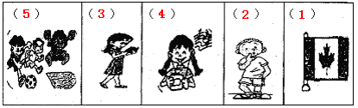

五、听，将每个人的姓名及其相关信息填入下面表格。所缺单词请参考旁边的词汇表。1×10

Word bank

|  |
| --- |
| four, five, seven,  eight, nine, ten, eleven,  twelve, quiet, shy,  active, funny, smart,  small, pretty |

|  |  |  |
| --- | --- | --- |
| Name | age | Character（性格） |
| Ken | **nine** | **funny** |
| Carol | **twelve** | **active** |
| Anna | **eleven** | **shy** |
| Tom | **ten** | **smart** |
| Cathy | **eight** | **quiet** |

笔试部分

一、先认一认，再找出每组中不属于同类的单词，并将其标号填在题前括号里。2×5

（**C**）1. A. turkey B. swan C. coach D. crane

（**D**）2. A. sister B. brother C. mother D. tailor

（**B**）3. A. France B. T-shirt C. Japan D. Germany

（**D**）4. A. waiter B. fireman C. driver D. maths

（**A**）5. A. hot B. green C. pink D. blue

二、选择填空。2×8

（**B**）1. I am _________ Class 1, Grade 5.

A. on B. in C. at

（**A**）2. My uncle _________ Japan.

A. is from B. come from C. comes in

（**B**）3. Let me introduce my parents _________ you.

A. for B. to C. of

（**C**）4. What’s your aunt? She’s a _________.

A. postman B. actor C. doctor

（**A**）5. Here is a photo _________ my family.

A. of B. for C. in

（**C**）6. Peter and Bob are _________.

A. twins brother B. twins brothers C. twin brothers

（**B**）7. I want to_________ an engineer in the future.

A. have B. be C. do

（**B**）8. Susan’s aunt _________ Japan.

A. is B. comes from C. comes in

三、读句子，左右栏的问句与答语对应搭配：2×5

（**C**）1. Where does she come from? A. No, he doesn’t.

（**B**）2. Does Mary like playing the piano? B. Yes, she does.

（**A**）3. Does Peter like writing? C. She comes from France.

（**D**）4. Where does she live? D. He lives in Canada.

（**E**）5. What’s your sister’s job? E. She is a dentist.

四、读句子，找出与句子内容相符的单词，把标号填在题前括号里。1×4

（**B**）1. It’s a large white water bird with a long thin neck.

（**D**）2. He works in a hospital. He helps ill people.

（**C**）3. He is very kind. He teaches us Chinese.

（**A**）4. It has two long ears. It likes to eat carrots.



五、读一读，将图片与相符文字内容连线。2×4

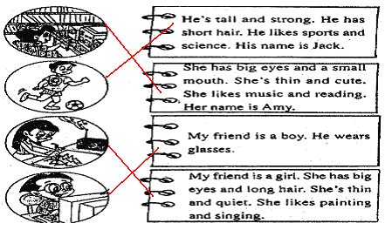

六、画一画你的爸爸和妈妈，让我们认识一下，他们是做什么呢？10

What’s your dad What’s your mum?



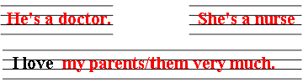

**画图略**

每画出一幅图给2分；每回答出一个正确问题给2分，若有拼写错误，但能看出已经理解了问题给1分；

听力原文：

一、1. painting 2. America 3. France 4. from

5. live 6. her 7. he’s 8. Germany

9. Britain 10. worker

二、1. My father is good at reading books.

2. It’s windy today.

3. My favourite animal is a dog.

4. The policeman has two big eyes, two small ears and a big mouth.

5. Peter’s uncle is a driver.

三、1. Who is the man?

2. What’s your mother’s job?

3. Jay comes from Tai Wan. He is a good singer.

Q: Can he sing songs?

4. A: Hi, Nancy. What is your job?

N: I am a teacher.

Q: Is Nancy a taxi driver?

5. A: Peter, I want to be a fireman in the future. How about you?

B: I want to be a good policeman.

Q: What does Peter want to be in the future?

四、1. Hi, I’m Bob. I’m from Canada. Nice to meet you.

2. Carl is a clever boy. He has short hair, small eyes and a small mouth.

3. Jean is my good friend. She has big eyes and long hair. She likes reading.

4. —Who’s that girl?

—Oh, she is my good friend Yang Xue. She likes music very much.

5. —Hi, Jack. What are you interested in?

—I’m interested in football and running. And you?

—I like sports, too.

五、1. Ken is nine. He looks funny.

2. Carol is twelve. She looks active.

3. Anna is eleven. She looks shy.

4. Tom is ten. He looks smart.

5. Cathy is eight. She looks quiet.

附：本次考试试卷总分100分。其中试题总分为98分，卷面书写